Urls heroku

<https://cloud-config-service-giorodrig.herokuapp.com/>

<https://cloud-discovery-service-gio.herokuapp.com/>

<https://cloud-shipping-service-giorod.herokuapp.com/>

pantallazo eureka

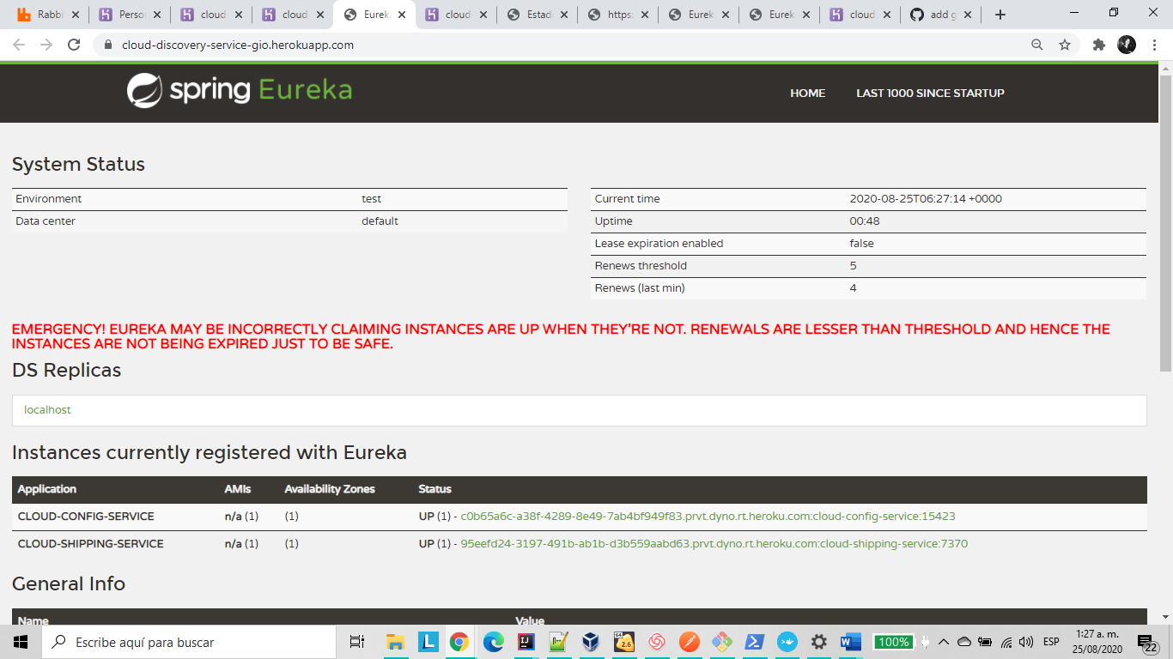

Pantallazo heroku

